
Mathematics Practical
University Of Delhi

Ramanujan College
DSC 03:Mathematics For Computing
Semester-1
(2023-24)

Submitted To:
~Dr. Aakash

Submitted By:
~Ratnesh Kumar

Acknowledgement
I would like to take this opportunity to acknowledge everyone who has helped us in every stage of this project.
I am deeply indebted to my mathematics Professor, Dr Aakash for his guidance and suggestions in completing this project. The completion of this project was possible under his guidance and support.
I am also very thankful to my parents and my friends who have boosted me up morally with their continuous support.
At last but not least, I am very thankful to God almighty for showering his blessings upon me.

Index
S.No | Practical Name
1 | Create And Transform Vectors And Matrices (The Transpose Vector (Matrix) Conjugate Transpose Of A Vector (Matrix)).
2 | Generate the matrix into echelon form and find its rank.
3 | Find Cofactors, Determinant, Adjoint And Inverse Of A Matrix.
4 | Solve A System Of Homogeneous And Non-Homogeneous Equations Using Gauss Elimination Method.
5 | Solve A System Of Homogeneous Equations Using The Gauss Jordan Method.
6 | Generate Basis Of Column Space, Null Space, Row Space And Left Null Space Of A Matrix Space.
7 | Check The Linear Dependence Of Vectors. Generate A Linear Combination Of Given Vectors Of Rn/ Matrices Of The Same Size And Find The Transition Matrix Of Given Matrix Space.
8 | Find The Orthonormal Basis Of Given Vectorspace Using The Gram-Schmidt Orthogonalization Process.
9 | Check The Diagonalizable Property Of Matrices And Find The Corresponding Eigenvalue And Verify The Cayley- Hamilton Theorem.
10 | Application Of Linear Algebra: Coding And Decoding Of Messages Using Non singular Matrices.  Eg Code “Linear Algebra Is Fun” And Then Decode It.
11 | Compute Gradient Of A Scalar Field.
12 | Compute Divergence Of A Vector Field.
13 | Compute Curl Of A Vector Field.

Create And Transform Vectors And Matrices (The Transpose Vector (Matrix) Conjugate Transpose Of A Vector (Matrix)).
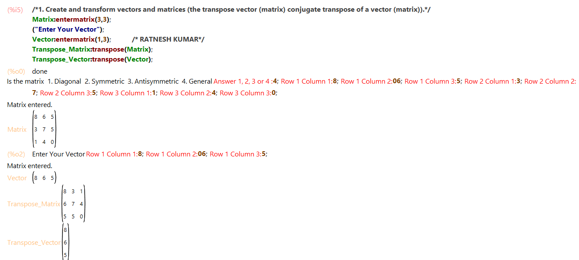
Generate The Matrix Into Echelon Form And Find Its Rank.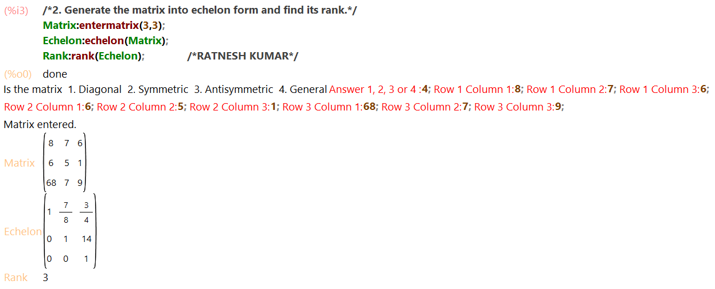
Find Cofactors, Determinant, Adjoint And Inverse Of A Matrix. 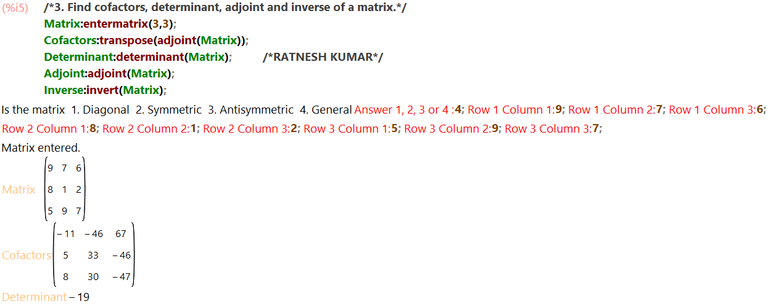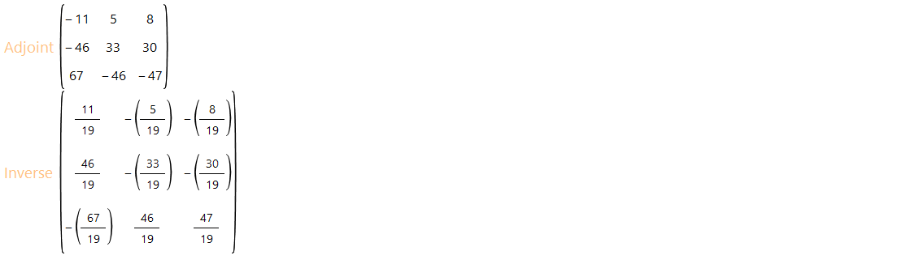

Solve A System Of Homogeneous And Non-Homogeneous Equations Using Gauss Elimination Method.
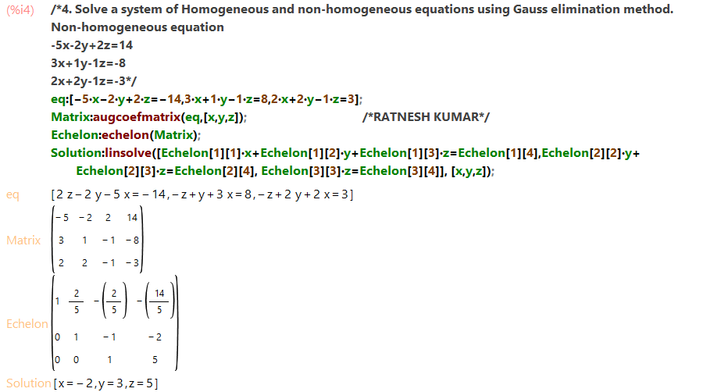
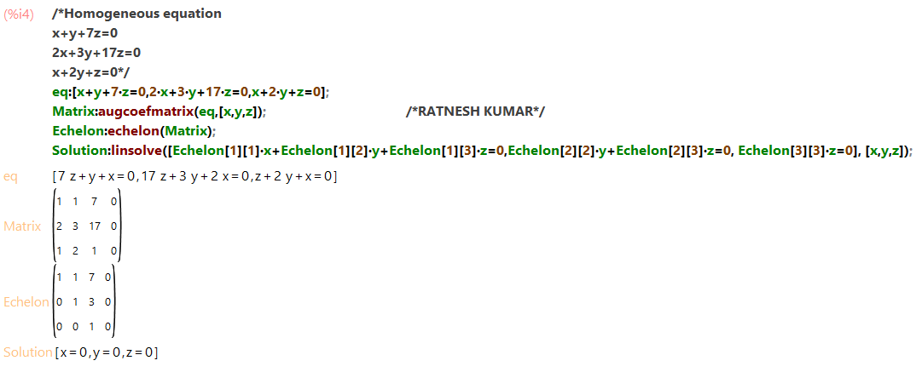

Solve A System Of Homogeneous Equations Using The Gauss Jordan Method.
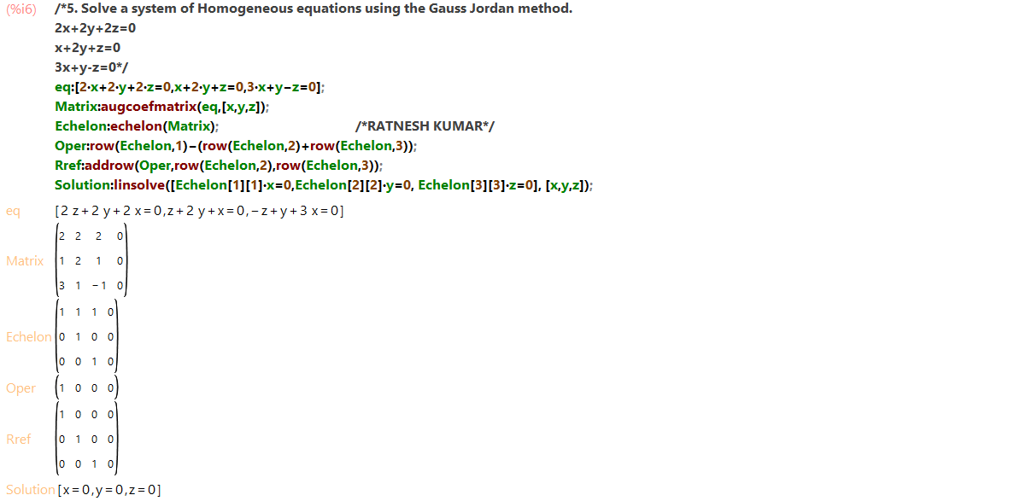

Generate Basis Of Column Space, Null Space, Row Space And Left Null Space Of A Matrix Space.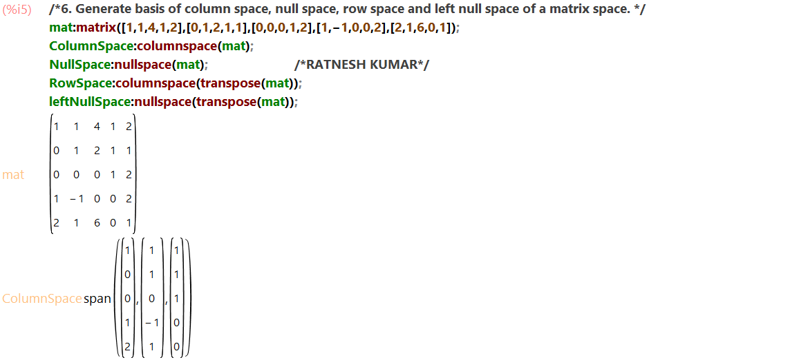
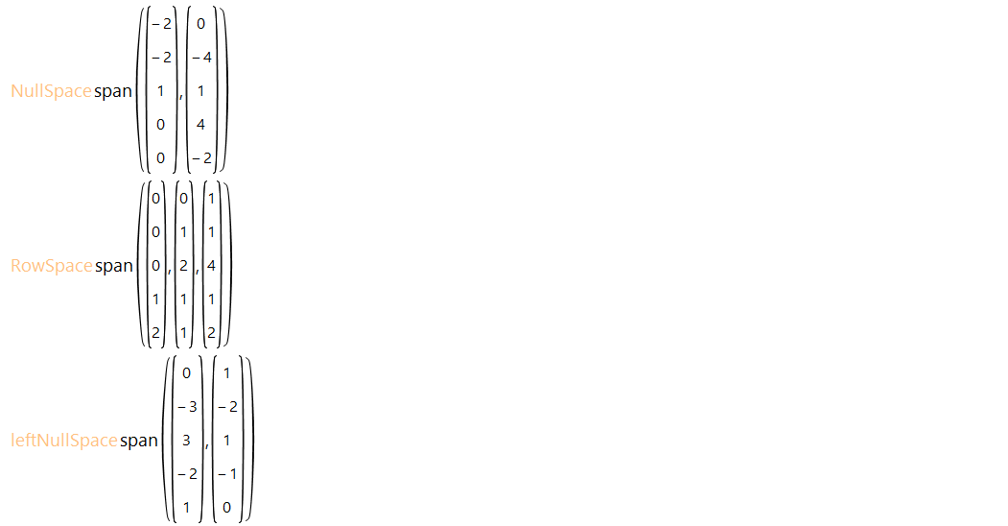

Check The Linear Dependence Of Vectors. Generate A Linear Combination Of Given Vectors Of Rn/ Matrices Of The Same Size And Find The Transition Matrix Of Given Matrix Space.
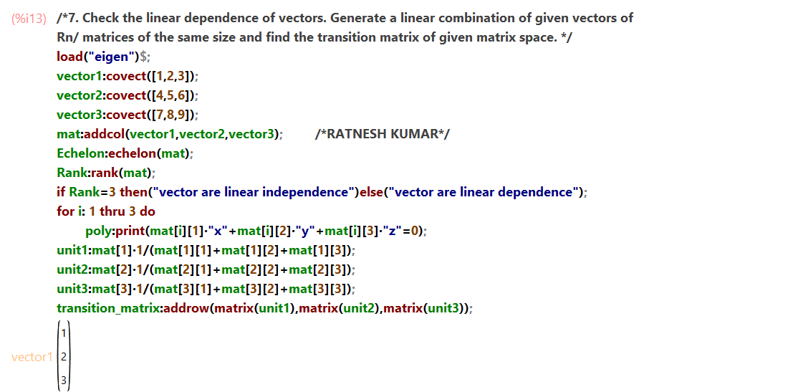
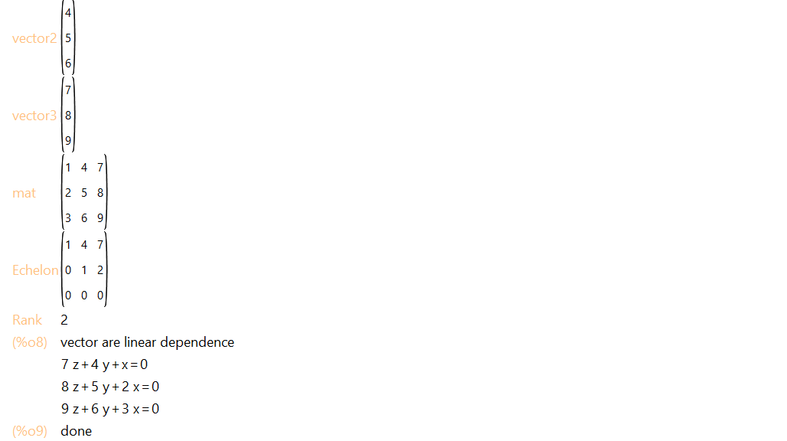
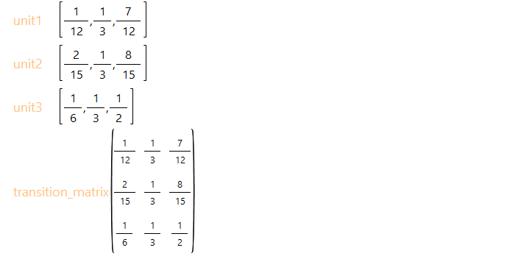
Find The Orthonormal Basis Of Given Vectorspace Using The Gram-Schmidt Orthogonalization Process.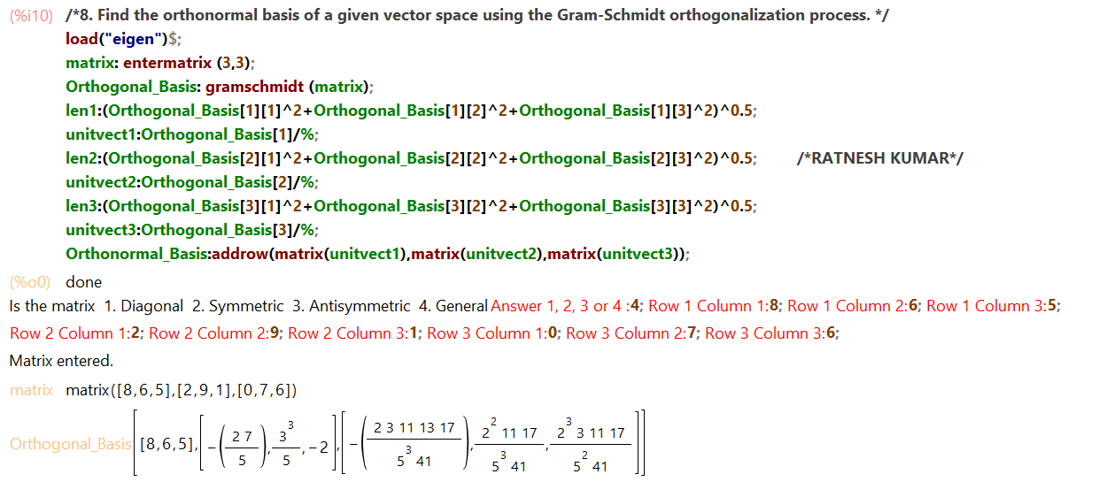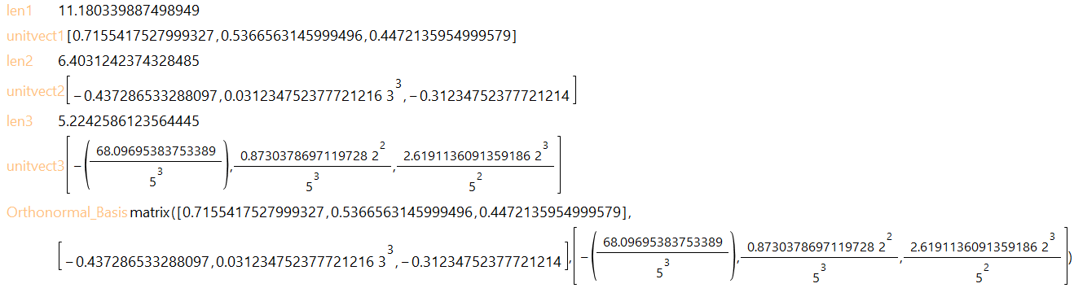

Check The Diagonalizable Property Of Matrices And Find The Corresponding Eigenvalue And Verify The Cayley- Hamilton Theorem.
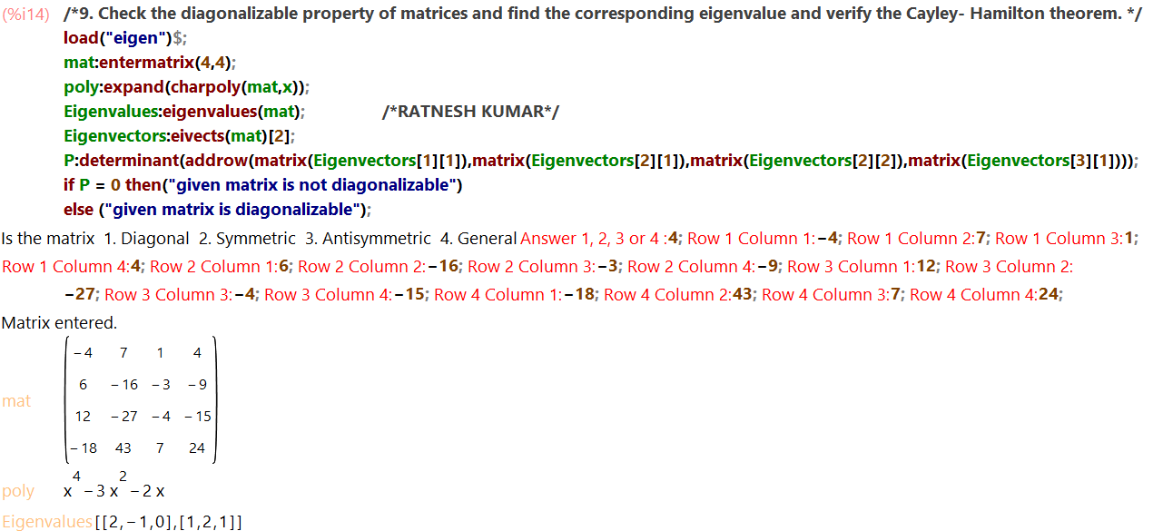
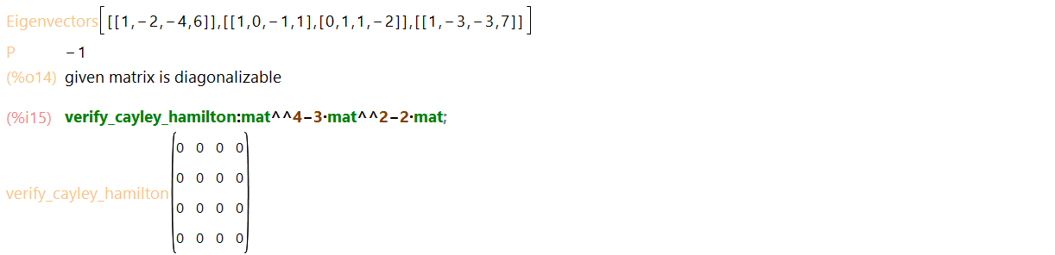

Application Of Linear Algebra: Coding And Decoding Of Messages Using Non singular Matrices.

Eg Code “Linear Algebra Is Fun” And Then Decode It.
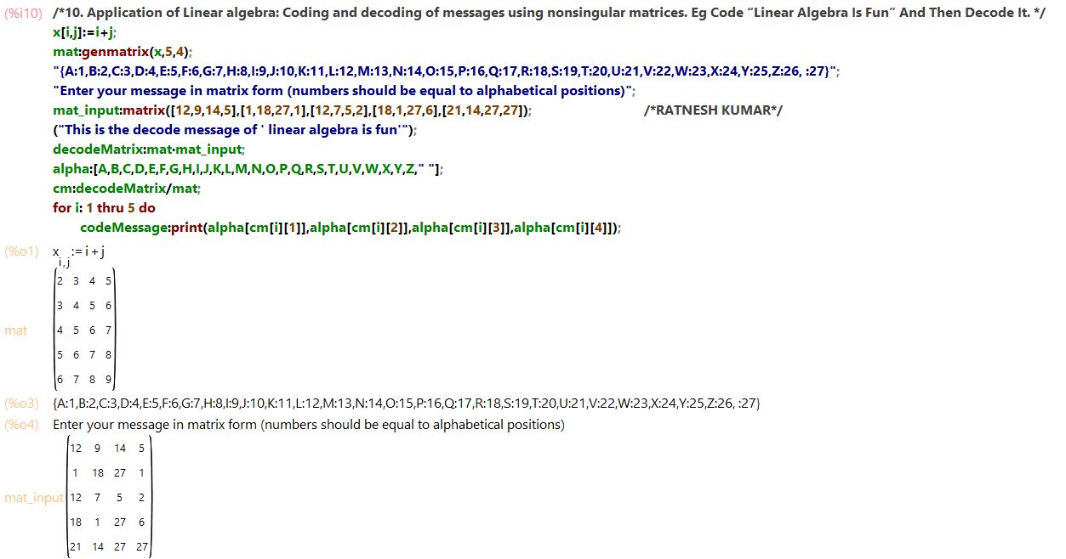
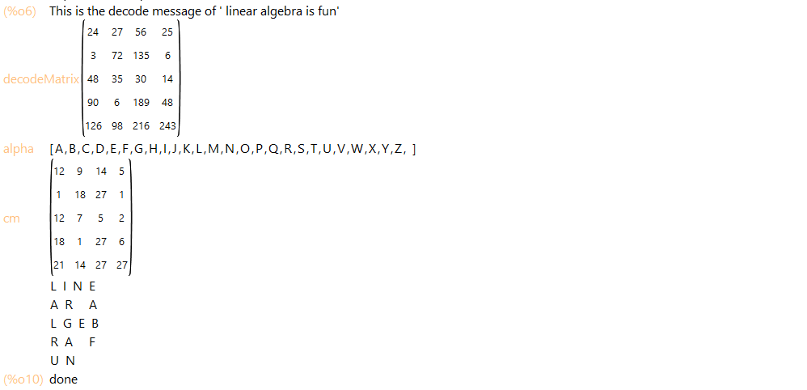
Compute Gradient Of A Scalar Field.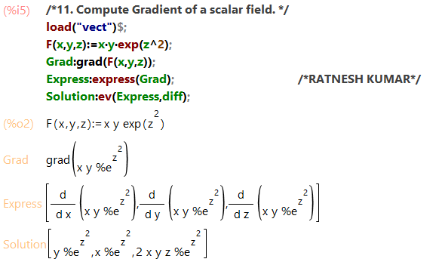

Compute Divergence Of A Vector Field.
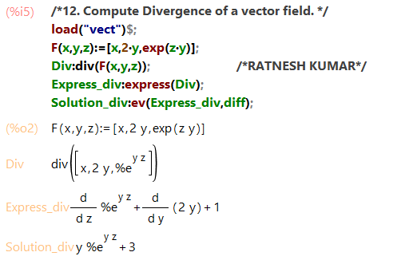

Compute Curl Of A Vector Field.
